**Welcome to the 2025 IPWDA Nationals**

Dear IPWDA Members

As President of the International Police Work Dog Association, it is my honor to welcome you to the 2025 IPWDA Nationals, taking please October 4-9, 2025, in Fayetteville, North Carolina.

This year’s Nationals are proudly hosted by the Fayetteville Police Department, Cumberland County Sheriff’s Office, Hope Mills Police Department and the Harnett County Sheriff’s Office. Their commitment and support have made it possible for us to come together for a week of professional growth and camaraderie.

The Nationals represent the very best of our association – an opportunity for members from across the United States to come together for training, certification, learning and the exchange of knowledge. Just as importantly, they allow us to build and strengthen the bonds that unite our K9 community.

Hotel Information, registration details, schedules for the weekend are enclosed in this letter. Once you arrive at the Crown Coliseum packets will be provided to each of you for the upcoming weeks events and festivities.

I look forward to an outstanding week and to the continued demonstration of professionalism, dedication, and teamwork that define IPWDA.

Thank you for your patience and for attending this year’s Nationals and for your ongoing commitment to the mission of our organization.

Respectfully

Tracy A Campbell

President

International Police Work Dog Association

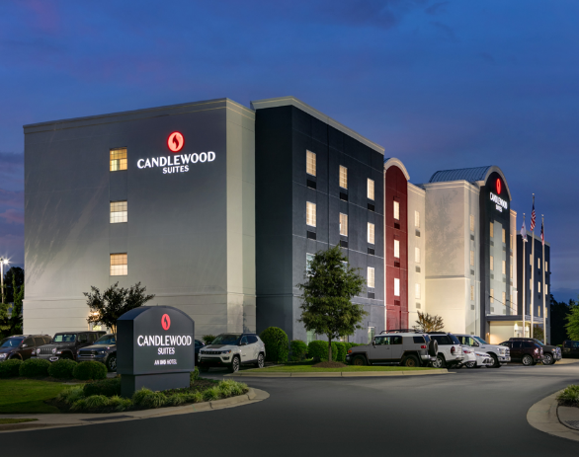**HOTEL ACCOMODATIONS**

**Candlewood Suites**

4108 Legend Avenue

Fayetteville, North Carolina 28303

(910) 868-0873

**NOTE:** [Executive Board & Master Trainers]

**Homewood Suites by Hilton**

4028 Legend Avenue

Fayetteville, North Carolina 28303

(910) 672-7800

**NOTE:** [IPWDA Members]

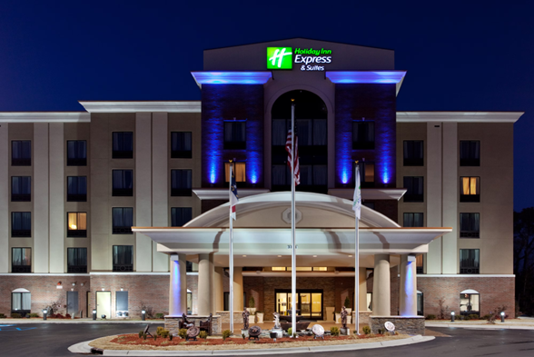

**Holiday Inn Express Hope Mills**

3111 North Main Street

Hope Mills, North Carolina

(910) 429-9990

**NOTE:** [IPWDA Members]

**2025 IPWDA SCHEDULE**

**REGISTRATION – GENERAL MEMBERSHIP MEETNG AND BANQUETS**

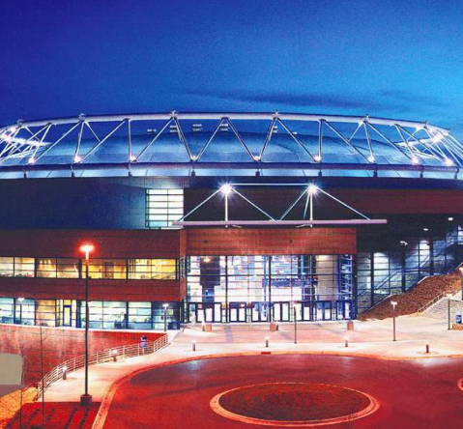

**Crown Coliseum Complex**

1960 Coliseum Drive

Fayetteville, NC 28306

(910) 438-4100

**DAILY SCHEDULE**

**Saturday, October 4, 2025**

0900-1200 hours Executive Board meeting – Crown Coliseum Complex

1200-1300 hours Lunch

1300 -1500 hours On-Line Testing – Crown Coliseum Complex

1500-1700 hours Oral Boards – Crown Coliseum Complex

**Sunday, October 4, 2025**

0900-1200 hours Executive Board meeting – Crown Coliseum Complex

1200-1300 hours Lunch

1200 -1500 hours Registration – Crown Coliseum Complex

1500-1800 hours Membership Meeting - Crown Coliseum Complex

1800-2100 hours Banquet - Crown Coliseum Complex

**Monday, October 6, 2025**

0800 - 0815 hours Daily Meeting – Crown Coliseum Complex

0900 - 1700 hours Certification / Training – See Schedule in Packet

0900 - 1200 hours Swift Water Training – FTCC

1200 - 1300 hours Lunch

1300 - 1600 hours Swift Water Training – FTCC

1500 - 1700 hours Vet Class – Fayetteville PD Training Center

1700 - 2100 hours Hospitability / Evening

**Tuesday, October 7, 2025**

0800 - 0815 hours Daily Meeting – Crown Coliseum Complex

0900 - 1700 hours Certification / Training – See Packets

0900 - 1200 hours Swift Water Training – FTCC

1200 - 1300 hours Lunch

1300 - 1600 hours Swift Water Training – FTCC

1500 - 1700 hours Vet Class – Fayetteville PD Training Center

1700 - 2100 hours Hospitability – Crown Coliseum Complex

**Wednesday, October 8, 2025**

0800 - 0815 hours Daily Meeting – Crown Coliseum Complex

0900 - 1700 hours Certification / Training

0900 - 1200 hours Swift Water Training – FTCC

1200 - 1300 hours Lunch

1300 – 1700 hours One Handed Pistol – Fayetteville PD Training

1300 - 1600 hours Swift Water Training – FTCC

1500 - 1700 hours Repelling - FTCC Fire Rescue Training Facility

1900 – 2100 hours Banquet - Crown Coliseum

**Thursday, October 9, 2025**

0800 Teams Depart

0800 - 0815 hours Daily Meeting – Crown Coliseum Complex

0900 - 1700 hours Problem Solving / Certification / Training

0900 - 1200 hours Swift Water Training – FTCC

1200 - 1300 hours Lunch

1300 – 1700 hours Clean-Up

**HOST COMMITTEE PHONE NUMBERS**

**Fayetteville Police Department**

Sgt. Candice Snyder 724-594-7287

**Cumberland County Sheriff’s Office**

Lt. Mark Lee 910-916-2088

**IPWDA President**

Tracy A Campbell 910-850-6192

**IPWDA Treasurer**

Heather Napieralski 910-624-4193

**Note:** Once you arrive at the Crown Coliseum we will have signs and Host Committee Officers in uniform for direction into the Coliseum.

Master Trainers needing transportation please ensure you make contact with Sgt. Snyder prior to your departure so we can ensure we are ready for your arrival.

Master Trainers once you arrive at the hotel you will only need to give them your name and Heather has taken care of the reservations.

Any questions do not hesiste to reach out to us.

